A­dvanced Topics in Research Methods and Design

Yi Chen

Columbia University

Exercise Four: Hierarchical Linear Growth Models

Note: The SPSS modeling exercises are finished by myself first, then checked and discussed with Jingru Zhang and Lesheng Xu. The proposal is finished completely by myself.

A­dvanced Topics in Research Methods and Design

# Problem 1: Exercises in Chapter 2

Note: Table 5.11 is not the output of SPSS, instead it is just a data definition table, which I will ignore in this exercise. Similarly, Table 5.3 is also not the output of SPSS but an orthogonal coding for measurement occasions.

## Table 5.2

* Data: ch5growthdata-vertical.sav
* Process:
  + Time 0, 1, and 2: analysis 🡺 descriptive statistics 🡺 explore 🡺 `test` as dependent list and `time` as factor list 🡺 remove unrequired statistics in the output (left plot).
  + Total: analysis 🡺 descriptive statistics 🡺 explore 🡺 `test` as dependent list only 🡺 remove unrequired statistics in the output (right plot).
* Note: we did not find the method to give the exact same output in SPSS. But all the relevant information can be obtained by our approach separately.
* Result

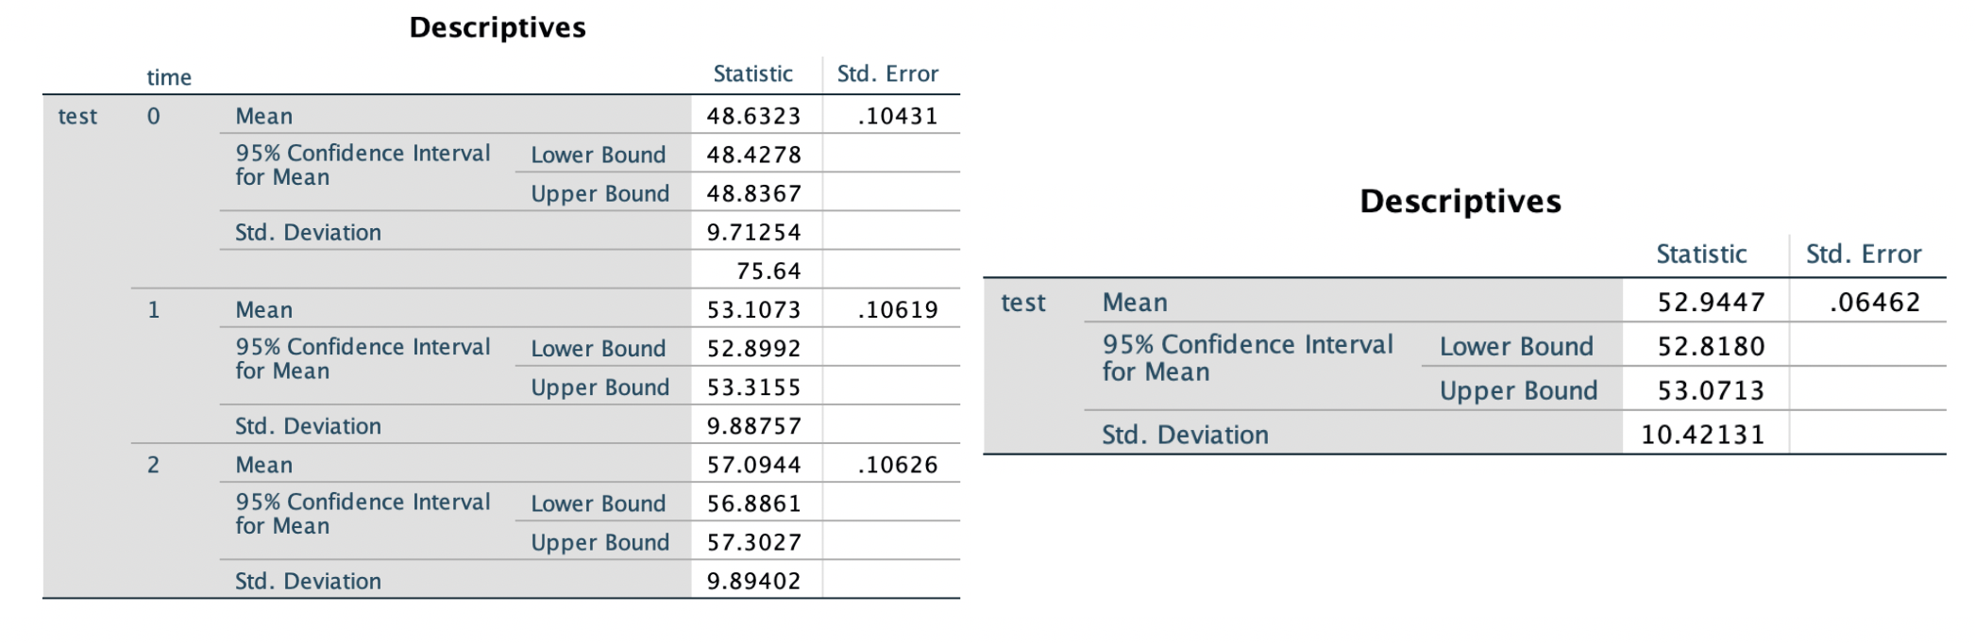

## We begin by examining descriptive statistics showing the level of the outcome means on each occasion, as summarized in Table 1. The table suggests that the average math achievement for the first occasion is 48.632, while for the last occasion it is 57.094, indicating considerable change over time. The table suggests that the grand mean is 52.945, which falls somewhere between the first and second measurement occasions. The grand mean is often not of much interest in examining growth since it just represents the average achievement level across the three measurement occasions. Examining the means more closely, one can see that the change between the first two test means is about 4.5 points, while between the second two means it is about 4.0. This suggests slightly less growth during the latter part of the trend compared with the initial part. The differences in observed means summarized in Table 1 suggest that they probably are not the same over time.

## 

## Figure 5.2

* Data: ch5growthdata-vertical.sav
* Process:
  + Select first 17 case: data 🡺 select case 🡺 if `id < 18`
  + Graph 🡺 scatter/Dot 🡺 Simple Scatter 🡺 `test` as Y axis, `time` as X axis, and set marketers by `id` 🡺 Add fit line at subgroups 🡺 loess 🡺 change the scale of X axis 🡺 delete unrequired information in the plot (left plot).
  + Graph 🡺 scatter/Dot 🡺 Simple Scatter 🡺 `test` as Y axis, `time` as X axis, and set marketers by `id` 🡺 Add fit line at subgroups 🡺 quadratic 🡺 change the scale of X axis 🡺 delete unrequired information in the plot (left plot).
* Result

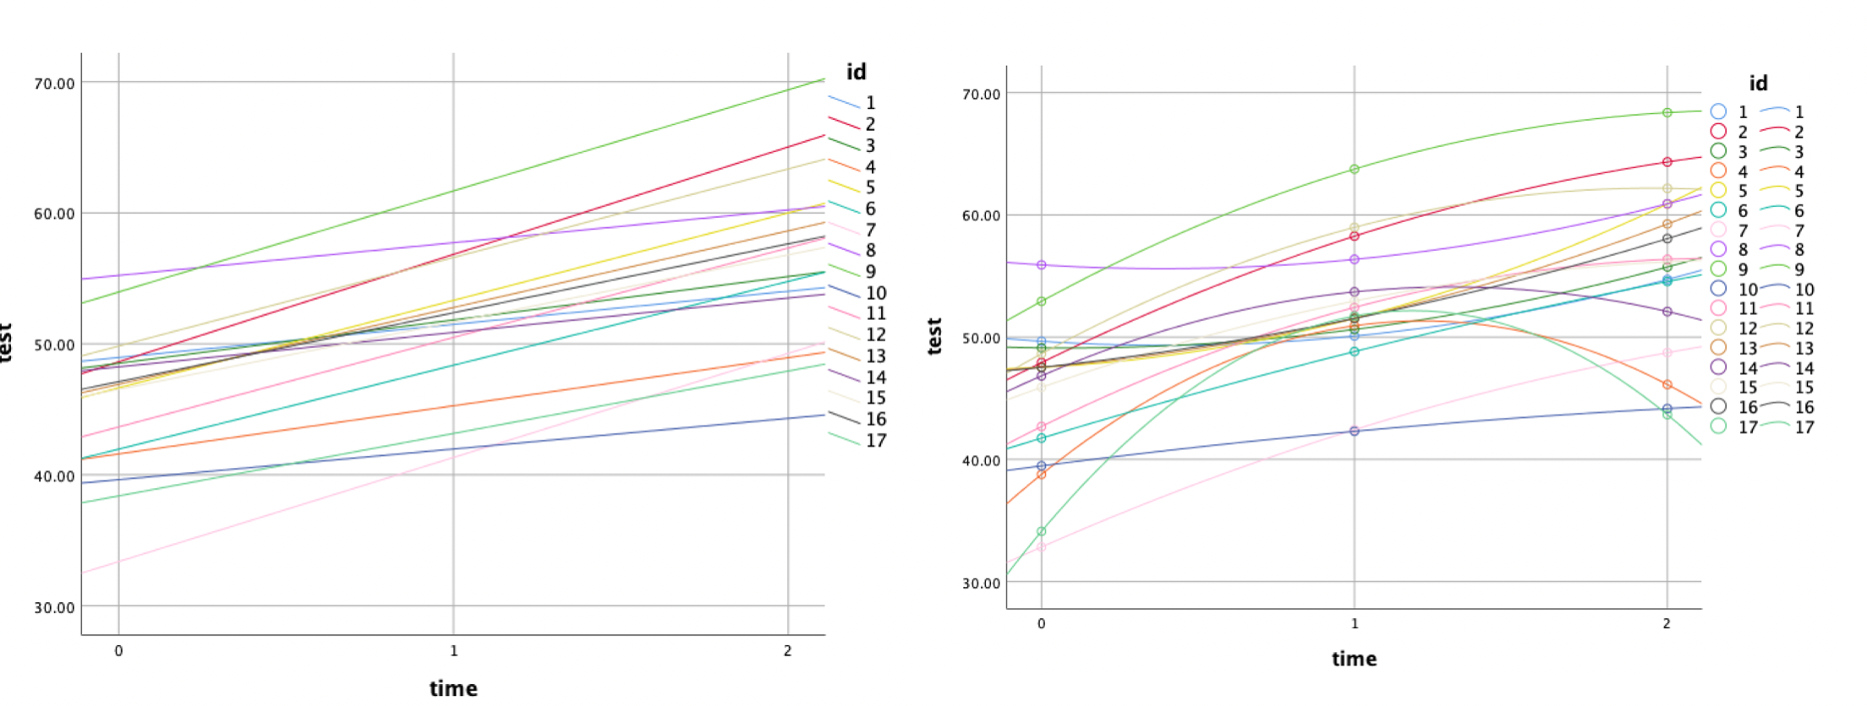

## Table 5.3

* Data: ch5growthdata-vertical.sav
* Process:
  + Analyze 🡺 Mixed Models 🡺 Linear 🡺 set `id` as subjects and `index1` as repeated 🡺 select repeated covariance type as `scaled identify` 🡺 set `test` as depended variable, while `time` as `quadtime` as covariables 🡺 in random: set covariance type as `scale identify`, include intercept, and add `id` into combinations 🡺 in estimation: select RMEL 🡺 in statistics: select parameter estimates, test for covariance parameters, and covariance of random effects.
* Model 1:
* 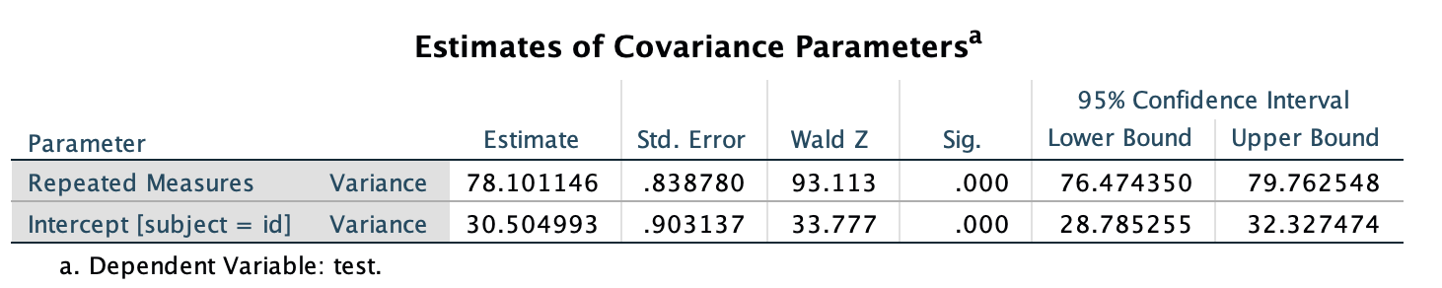Result
* Interpretations:
  + Table 5.4 represent the variance component at each level, which indicates how much variability in dependent variable (test) is present at level 1 (variability in the average individuals’ achievement estimates around its true growth trajectory; 78) and level 2 (variability between individuals; 30). Both variances are significantly unequal to zero, which means there exist certain level of effect from both level 1 and level 2. The proportion of between individual variance (ICC) is about 28%.
  + The fix effects indicate that the intercept in this model (the average initial status mean between individuals) is significantly different from 0. And the average test mean is about 53 (regardless of subject and test id).
  + 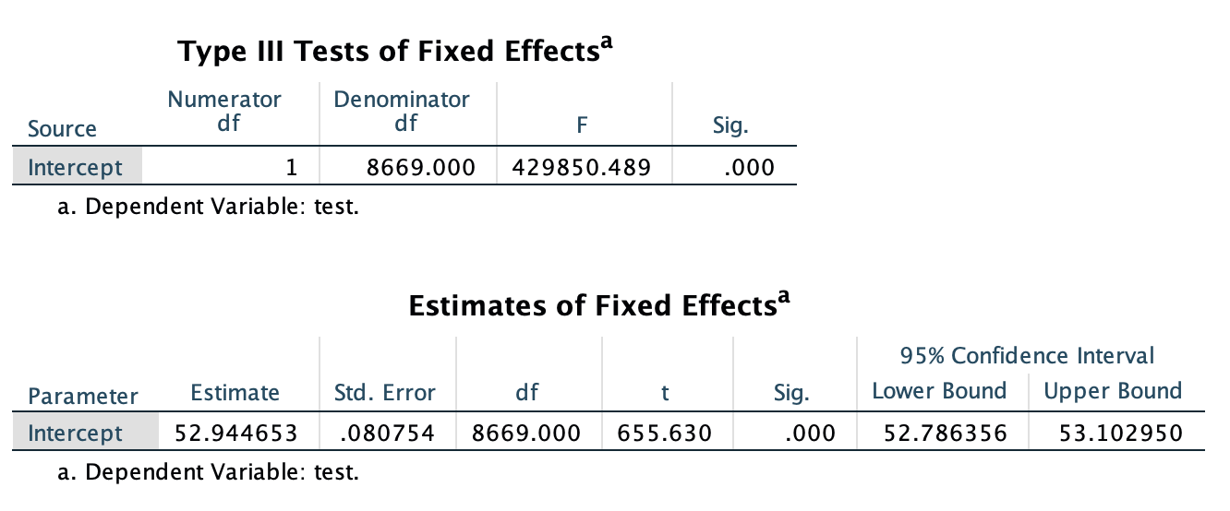The scale identity is used in for covariance matrix, which assume there is no covariance between occasions (tests), and the variances across occasions (tests) are constant. This may be a too strong assumption, since we have already seen from the Table 5.2 that the standard deviation across tests are not the same.

## Table 5.5 & 5.6

* Data: ch5growthdata-vertical.sav
* Process:
  + Analyze 🡺 Mixed Models 🡺 Linear 🡺 set `id` as subjects and `index1` as repeated 🡺 select repeated covariance type as `scaled identify` 🡺 set `test` as depended variable, while `time` as `quadtime` as covariables 🡺 in random: set covariance type as `scale identify`, include intercept, and add `id` into combinations 🡺 in estimation: select RMEL 🡺 in statistics: select parameter estimates, test for covariance parameters, and covariance of random effects. 🡺 *select `time` and `quadtime` as fixed main effects.*
* Model:
* Result

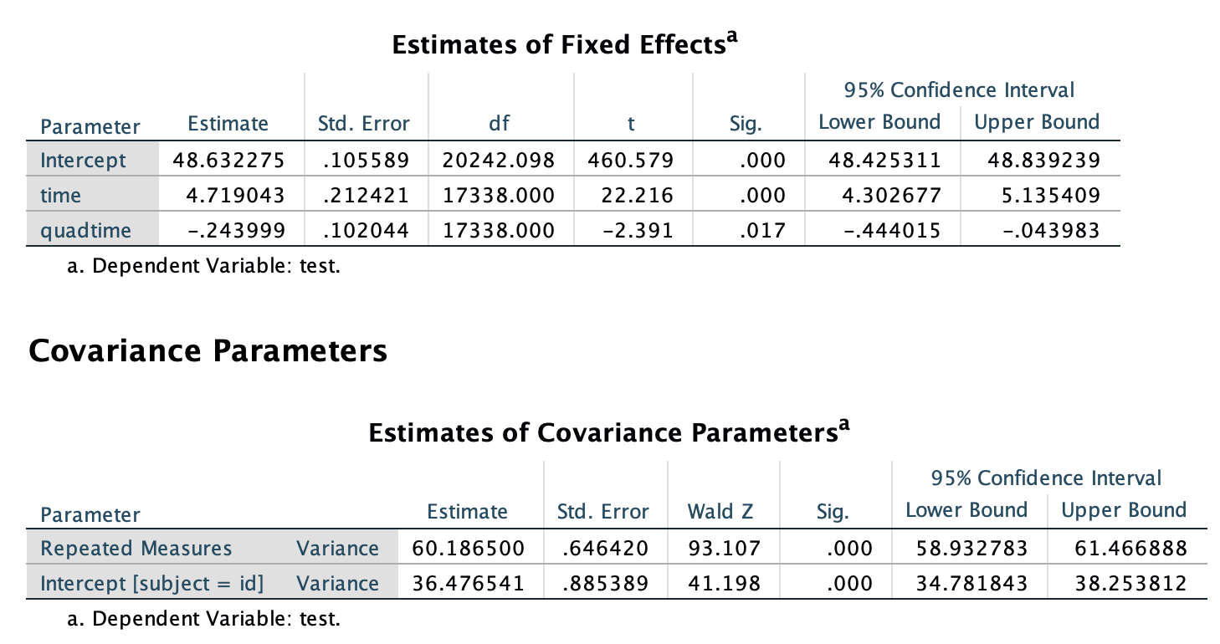

* Interpretations:
  + For fixed effects: the estimated coefficients for intercept, time, and quadtime are 48.63, 4.7 and -0.2. All of them are significantly different from 0, which indicates that they are significant in explaining the growth in test.
  + The within-individual variance is 60 and between individual variance is 36. The ICC this time becomes 37.5%. The variability in both variances are significant.

## Table 5.7, 5.8 & 5.9

* Data: ch5growthdata-vertical.sav
* Syntax:

MIXED test WITH time quadtime  
  /CRITERIA=DFMETHOD(SATTERTHWAITE) CIN(95) MXITER(100) MXSTEP(10) SCORING(1)  
    SINGULAR(0.000000000001) HCONVERGE(0, ABSOLUTE) LCONVERGE(0, ABSOLUTE) PCONVERGE(0.000001, ABSOLUTE)  
  /FIXED=time quadtime | SSTYPE(3)  
  /METHOD=REML  
  /PRINT=G  SOLUTION TESTCOV  
  /RANDOM=INTERCEPT time | SUBJECT(id) COVTYPE(UN)  
  /REPEATED=Index1 | SUBJECT(id) COVTYPE(ID).

* Model:
* 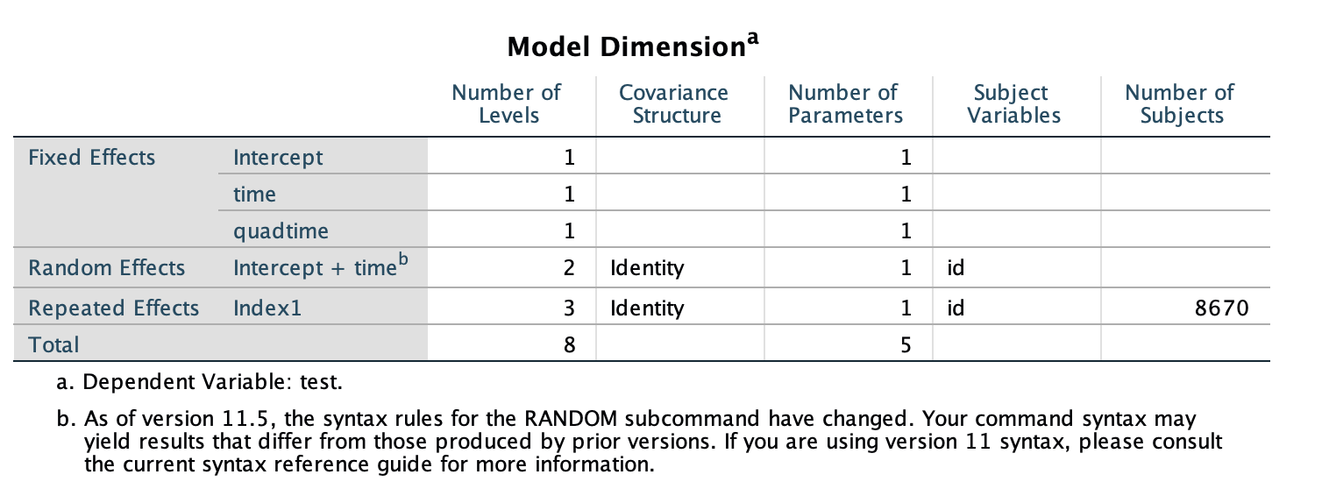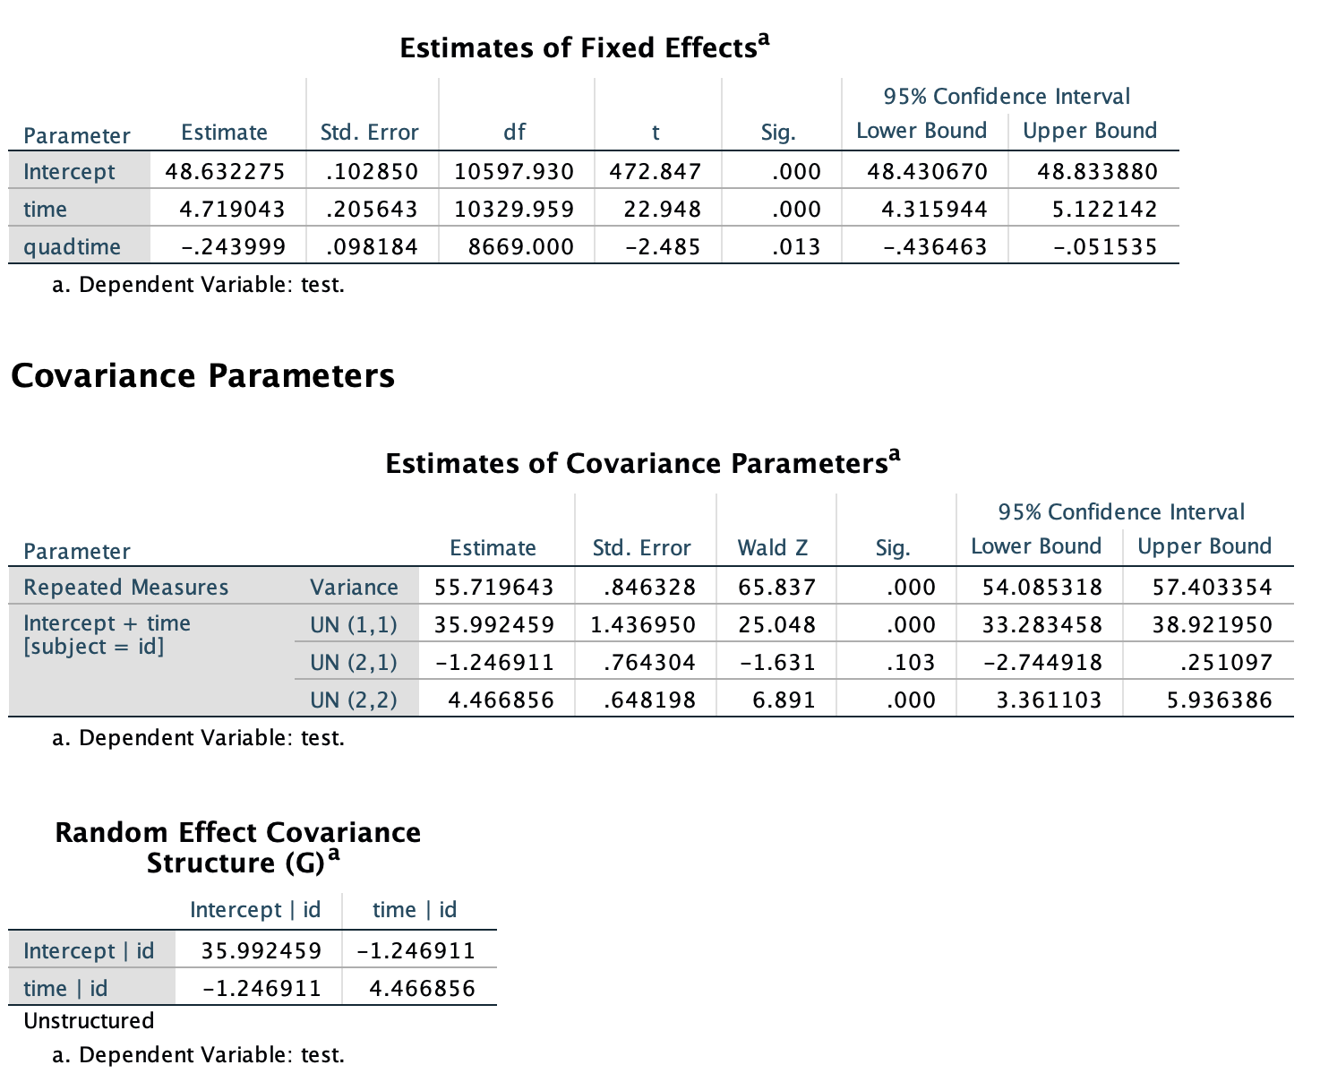Result

|  |  |  |  |  |  |  |  |  |
| --- | --- | --- | --- | --- | --- | --- | --- | --- |
| Source | | Type III Sum of Squares | df | Mean Square | F | Sig. | Noncent. Parameter | Observed Powera |
| time | Linear | 310416.221 | 1 | 310416.221 | 4801.239 | 0.000 | 4801.239 | 1.000 |
| Quadratic | 344.115 | 1 | 344.115 | 6.176 | 0.013 | 6.176 | 0.700 |
| Error(time) | Linear | 560479.947 | 8669 | 64.653 |  |  |  |  |
| Quadratic | 483033.589 | 8669 | 55.720 |  |  |  |  |
| a. Computed using alpha = .05 | | | | | | | | |

* Interpretations:
  + For fixed effects: the estimated coefficients for intercept, time, and quadtime are 48.63, 4.7 and -0.2. All of them are significantly different from 0, which indicates that they are significant in explaining the growth in test. The result is similar to the previous one. While the standard deviation for all variables becomes smaller after adding the random effects.
  + The within-individual variance is 56. At level 2, the unconstructed covariance matrix indicates the variance estimates for random intercept (UN,1,1) is 36, the random linear slope (UN, 2,2) is 4.5, and the covariance between them (UN,1,2) is -1.2. The variability in random intercept and random linear slop are both significant. While, there covariance is not significant, which means it may be better to choose the diagonal covariance type.
  + If we take the square root of the F tests for the time-related contrasts (4,801.239) for the linear contrast and for the quadratic contrast (6.176), we obtain the t tests for the contrasts. This suggests that the MIXED solution with orthogonal polynomial linear and quadratic contrasts is consistent with the repeated measures ANOVA solution for the time-related effects.

## Table 5.10 & 5.12

* Data: ch5growthdata-vertical.sav
* Syntax:

MIXED test WITH orthtime orthquad  
  /CRITERIA=DFMETHOD(SATTERTHWAITE) CIN(95) MXITER(100) MXSTEP(10) SCORING(1)  
    SINGULAR(0.000000000001) HCONVERGE(0, ABSOLUTE) LCONVERGE(0, ABSOLUTE) PCONVERGE(0.000001, ABSOLUTE)  
  /FIXED=orthtime orthquad | SSTYPE(3)  
  /METHOD=REML  
  /PRINT=G  SOLUTION TESTCOV  
  /RANDOM=INTERCEPT orthtime | SUBJECT(id) COVTYPE(UN)  
  /REPEATED=Index1 | SUBJECT(id) COVTYPE(ID).

* Model:
* 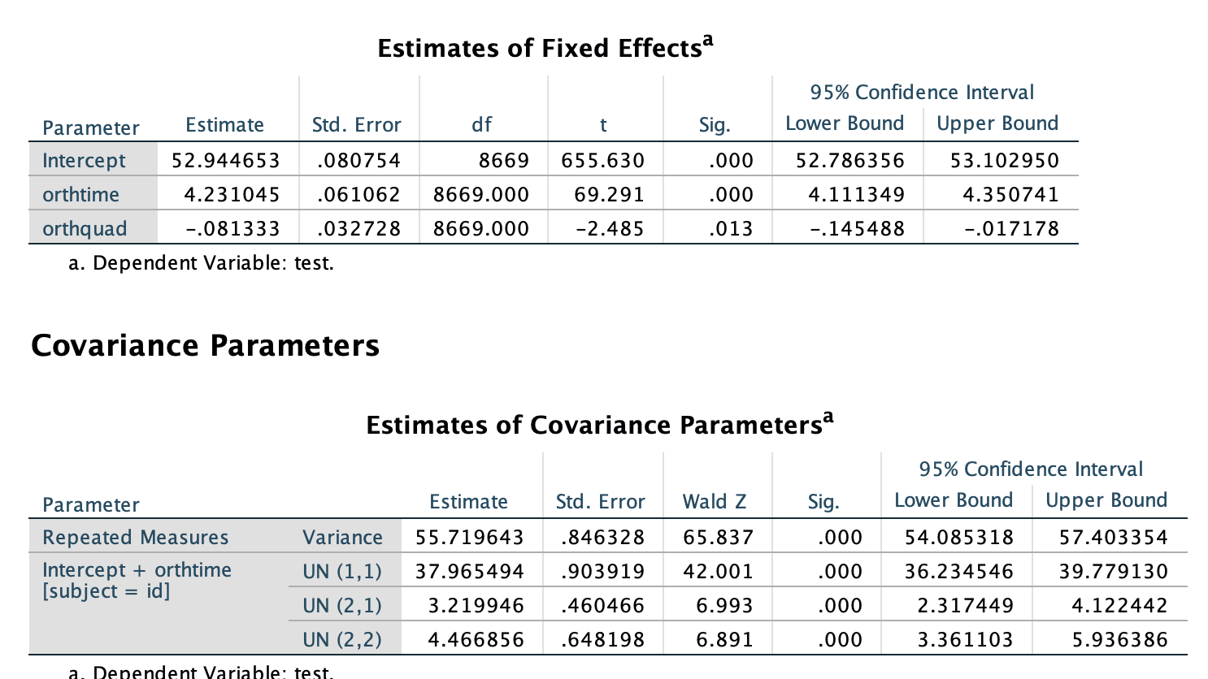Result
* Interpretations:
  + For fixed effects: the estimated coefficients for intercept, time, and quadtime are 53, 4.2 and -0.08. All of them are significantly different from 0, which indicates that they are significant in explaining the growth in test. The standard deviation for all variables becomes smaller after adding the random effects.
  + The within-individual variance is 56. At level 2, the unconstructed covariance matrix indicates the variance estimates for random intercept (UN,1,1) is 38, the random linear slope (UN, 2,2) is 3.2, and the covariance between them (UN,1,2) is 4.5. The variability in random intercept and random linear slop and their covariance are both significant.

## Table 5.13 & 5.14

* Data: ch5growthdata-vertical.sav
* Syntax:
  + Model 1

MIXED test WITH orthtime orthquad  
  /CRITERIA=DFMETHOD(SATTERTHWAITE) CIN(95) MXITER(100) MXSTEP(10) SCORING(1)  
    SINGULAR(0.000000000001) HCONVERGE(0, ABSOLUTE) LCONVERGE(0, ABSOLUTE) PCONVERGE(0.000001, ABSOLUTE)  
  /FIXED=orthtime orthquad | SSTYPE(3)  
  /METHOD=REML  
  /PRINT=G  SOLUTION TESTCOV  
  /RANDOM=INTERCEPT orthtime | SUBJECT(id) COVTYPE(UN)  
  /REPEATED=Index1 | SUBJECT(id) COVTYPE(ID).

* + Model 2

MIXED test WITH orthtime orthquad  
  /CRITERIA=DFMETHOD(SATTERTHWAITE) CIN(95) MXITER(100) MXSTEP(10) SCORING(1)  
    SINGULAR(0.000000000001) HCONVERGE(0, ABSOLUTE) LCONVERGE(0, ABSOLUTE) PCONVERGE(0.000001, ABSOLUTE)  
  /FIXED=orthtime orthquad | SSTYPE(3)  
  /METHOD=REML  
  /PRINT=G  SOLUTION TESTCOV  
  /RANDOM=INTERCEPT orthtime | SUBJECT(id) COVTYPE(DIAG)  
  /REPEATED=Index1 | SUBJECT(id) COVTYPE(DIAG).

* + Model 3

MIXED test WITH orthtime orthquad  
  /CRITERIA=DFMETHOD(SATTERTHWAITE) CIN(95) MXITER(100) MXSTEP(10) SCORING(1)  
    SINGULAR(0.000000000001) HCONVERGE(0, ABSOLUTE) LCONVERGE(0, ABSOLUTE) PCONVERGE(0.000001, ABSOLUTE)  
  /FIXED=orthtime orthquad | SSTYPE(3)  
  /METHOD=REML  
  /PRINT=G  SOLUTION TESTCOV  
  /RANDOM=INTERCEPT orthtime | SUBJECT(id) COVTYPE(UN)  
  /REPEATED=Index1 | SUBJECT(id) COVTYPE(DIAG).

* + Model 4

MIXED test WITH orthtime orthquad  
  /CRITERIA=DFMETHOD(SATTERTHWAITE) CIN(95) MXITER(100) MXSTEP(10) SCORING(1)  
    SINGULAR(0.000000000001) HCONVERGE(0, ABSOLUTE) LCONVERGE(0, ABSOLUTE) PCONVERGE(0.000001, ABSOLUTE)  
  /FIXED=orthtime orthquad | SSTYPE(3)  
  /METHOD=REML  
  /PRINT=G  SOLUTION TESTCOV  
  /RANDOM=INTERCEPT orthtime | SUBJECT(id) COVTYPE(DIAG)  
  /REPEATED=Index1 | SUBJECT(id) COVTYPE(AR1).

* Model (same for all the four model expect for the variance-covariance matrix designs):
* Result
  + Model 1

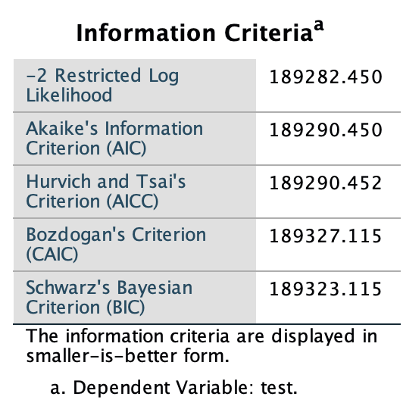

* + Model 2

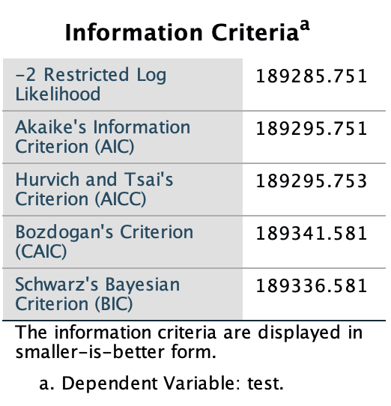

* + Model 3

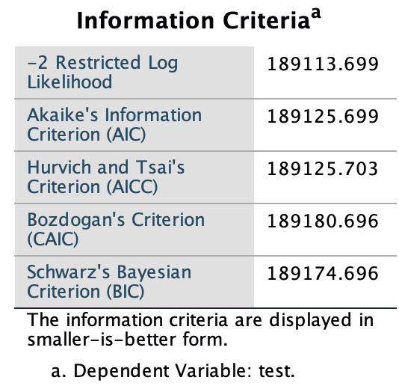

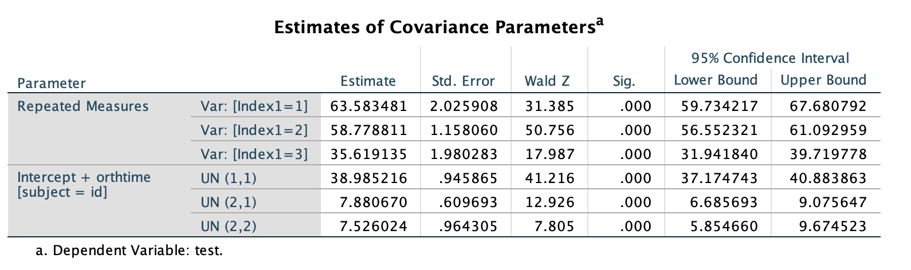

* + Model 4

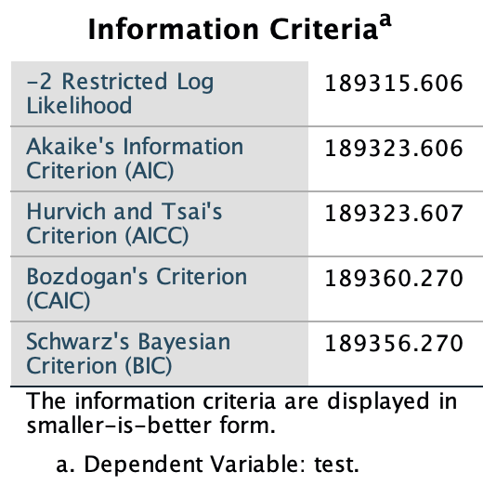

* Interpretation
  + Based on the information criteria, the best model should be the one with smallest AIC or BIC. The model 3 is the best model, which have relative bigger likelihood and smaller number of parameters.
  + Based on model 3, large amount of variability can be seen in different occasions and their variabilities are different.

## Table 5.15, 5.16, 5.17, & 5.18

* Data: ch5growthdata-vertical.sav
* Syntax:
  + Model 1

MIXED test WITH orthtime orthquad effective ses

/CRITERIA=DFMETHOD(SATTERTHWAITE) CIN(95) MXITER(100) MXSTEP(10) SCORING(1)

SINGULAR(0.000000000001) HCONVERGE(0, ABSOLUTE) LCONVERGE(0, ABSOLUTE) PCONVERGE(0.000001, ABSOLUTE)

/FIXED=orthtime orthquad effective ses orthtime*ses orthtime*effective | SSTYPE(3)

/METHOD=REML

/PRINT=G SOLUTION TESTCOV

/RANDOM=INTERCEPT orthtime | SUBJECT(id) COVTYPE(UN)

/REPEATED=Index1 | SUBJECT(id) COVTYPE(DIAG).

* Model
* Result

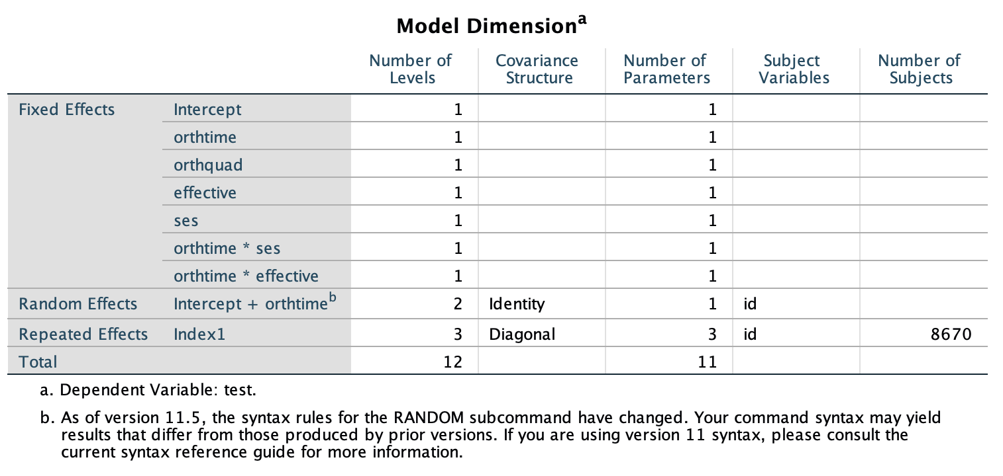

|  |  |  |  |  |  |  |  |  |
| --- | --- | --- | --- | --- | --- | --- | --- | --- |
| Source | | Type III Sum of Squares | df | Mean Square | F | Sig. | Noncent. Parameter | Observed Powera |
| time | Linear | 283779.090 | 1 | 283779.090 | 4795.547 | 0.000 | 4795.547 | 1.000 |
| Quadratic | 637.493 | 1 | 637.493 | 11.551 | 0.001 | 11.551 | 0.925 |
| time * ses | Linear | 244.668 | 1 | 244.668 | 4.135 | 0.042 | 4.135 | 0.529 |
| Quadratic | 1.270 | 1 | 1.270 | 0.023 | 0.879 | 0.023 | 0.053 |
| time * effective | Linear | 47359.91 | 1 | 47359.971 | 800.330 | 0.000 | 800.330 | 1.000 |
| Quadratic | 4712.361 | 1 | 4712.361 | 85.386 | 0.000 | 85.386 | 1.000 |
| Error(time) | Linear | 512874.459 | 8667 | 59.176 |  |  |  |  |
| Quadratic | 478319.939 | 8667 | 55.189 |  |  |  |  |
| a. Computed using alpha = .05 | | | | | | | | |

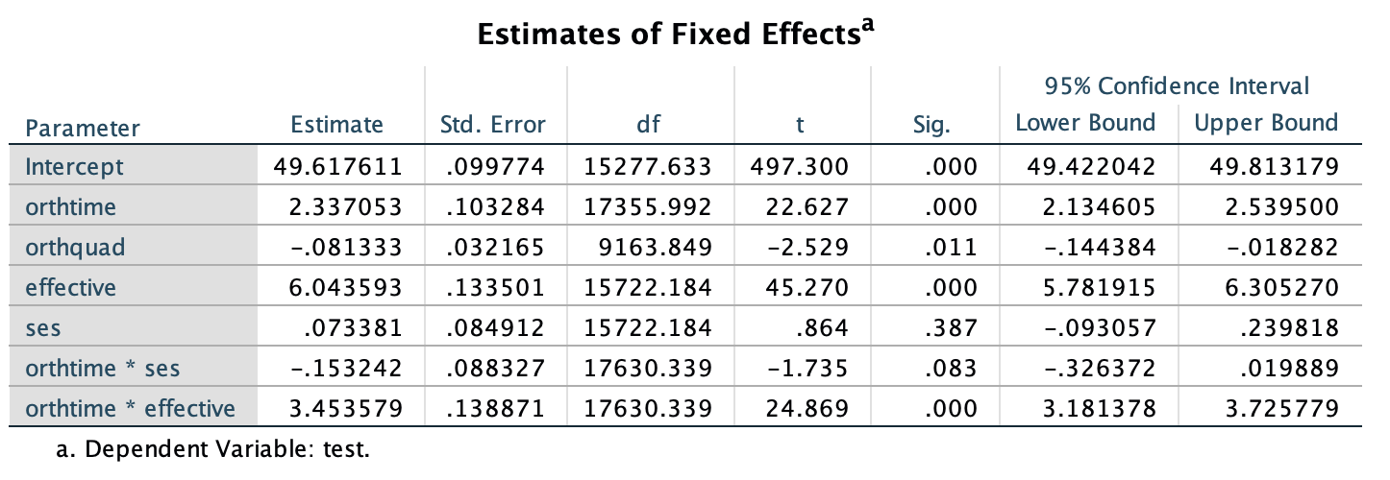

# 

* Interpretation:
  + For the fixed effect: intercept, orthogonal time, orthogonal quadratic time, effectives, and orthogonal time by effective have significant effect on the growth of test performance.
  + For random effect: the variability in each occasion are different and significant. The random intercept effect, random orthogonal time effect, and their covariance are all significant.
  + For comparative purposes in Table 16, we also provide the repeated measures ANOVA solution that we would obtain for the polynomial contrasts. The relevant output is the tests of within-subject contrasts. That solution also has additional tests of contrasts for the quadratic time-related component and the predictors in the model (i.e., SES and teacher effectiveness). We can see that the linear effect is also significant for individual SES in the ANOVA formulation (but the quadratic effect is not), and the linear and quadratic effects are both significant for effective (p < .001) We could of course provide this same set of model tests using MIXED by adding the two quadratic contrasts to the fixed-effect model.

## Table 5.19

* Data: ch5growthdata-vertical.sav
* Syntax:
  + Model 1

MIXED test WITH time quadtime  
  /CRITERIA=DFMETHOD(SATTERTHWAITE) CIN(95) MXITER(100) MXSTEP(10) SCORING(1)  
    SINGULAR(0.000000000001) HCONVERGE(0, ABSOLUTE) LCONVERGE(0, ABSOLUTE) PCONVERGE(0.000001, ABSOLUTE)  
  /FIXED=time quadtime | SSTYPE(3)  
  /METHOD=REML  
  /PRINT=G  SOLUTION TESTCOV  
/RANDOM=INTERCEPT time | SUBJECT(id) COVTYPE(UN)s  
  /REPEATED=Index1 | SUBJECT(id) COVTYPE(DIAG).

* + Model 2

MIXED test WITH time quadtime effective ses  
  /CRITERIA=DFMETHOD(SATTERTHWAITE) CIN(95) MXITER(100) MXSTEP(10) SCORING(1)  
    SINGULAR(0.000000000001) HCONVERGE(0, ABSOLUTE) LCONVERGE(0, ABSOLUTE) PCONVERGE(0.000001, ABSOLUTE)  
  /FIXED=time quadtime effective ses time*effective time*ses | SSTYPE(3)  
  /METHOD=REML  
  /PRINT=G  SOLUTION TESTCOV  
/RANDOM=INTERCEPT time | SUBJECT(id) COVTYPE(UN)  
  /REPEATED=Index1 | SUBJECT(id) COVTYPE(DIAG).

* + Model 3

MIXED test WITH orthtime orthquad  
  /CRITERIA=DFMETHOD(SATTERTHWAITE) CIN(95) MXITER(100) MXSTEP(10) SCORING(1)  
    SINGULAR(0.000000000001) HCONVERGE(0, ABSOLUTE) LCONVERGE(0, ABSOLUTE) PCONVERGE(0.000001, ABSOLUTE)  
  /FIXED=orthtime orthquad | SSTYPE(3)  
  /METHOD=REML  
  /PRINT=G  SOLUTION TESTCOV  
/RANDOM=INTERCEPT orthtime | SUBJECT(id) COVTYPE(UN)  
  /REPEATED=Index1 | SUBJECT(id) COVTYPE(DIAG).

* + Model 4

MIXED test WITH orthtime orthquad effective ses  
  /CRITERIA=DFMETHOD(SATTERTHWAITE) CIN(95) MXITER(100) MXSTEP(10) SCORING(1)  
    SINGULAR(0.000000000001) HCONVERGE(0, ABSOLUTE) LCONVERGE(0, ABSOLUTE) PCONVERGE(0.000001, ABSOLUTE)  
  /FIXED=orthtime orthquad effective ses orthtime*effective orthtime*ses | SSTYPE(3)  
  /METHOD=REML  
  /PRINT=G  SOLUTION TESTCOV  
/RANDOM=INTERCEPT orthtime | SUBJECT(id) COVTYPE(UN)  
  /REPEATED=Index1 | SUBJECT(id) COVTYPE(DIAG).

* + Model 5

MIXED test WITH orthtime orthquad effective ses  
  /CRITERIA=DFMETHOD(SATTERTHWAITE) CIN(95) MXITER(100) MXSTEP(10) SCORING(1)  
    SINGULAR(0.000000000001) HCONVERGE(0, ABSOLUTE) LCONVERGE(0, ABSOLUTE) PCONVERGE(0.000001, ABSOLUTE)  
  /FIXED=orthtime orthquad effective ses orthtime*effective orthtime*ses orthquad*effective  
    orthquad*ses | SSTYPE(3)  
  /METHOD=REML  
  /PRINT=G  SOLUTION TESTCOV  
/RANDOM=INTERCEPT orthtime | SUBJECT(id) COVTYPE(UN)  
  /REPEATED=Index1 | SUBJECT(id) COVTYPE(DIAG).

* Note: There is a typo in table 5.19. The interaction effect should be orthtime * effective instead of orth-quadratic * effective for the first appearance.
* Model
  + Model 1:
  + Model 2:
  + Model 3:
  + Model 4:
  + Model 5:
* Result
  + Model 1

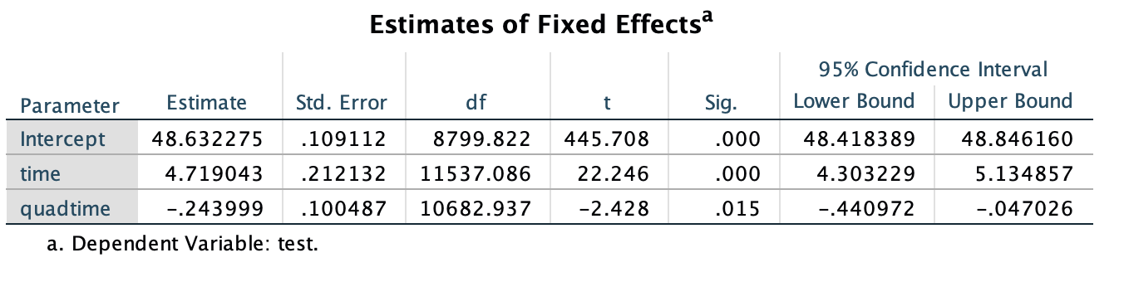

* + Model 2

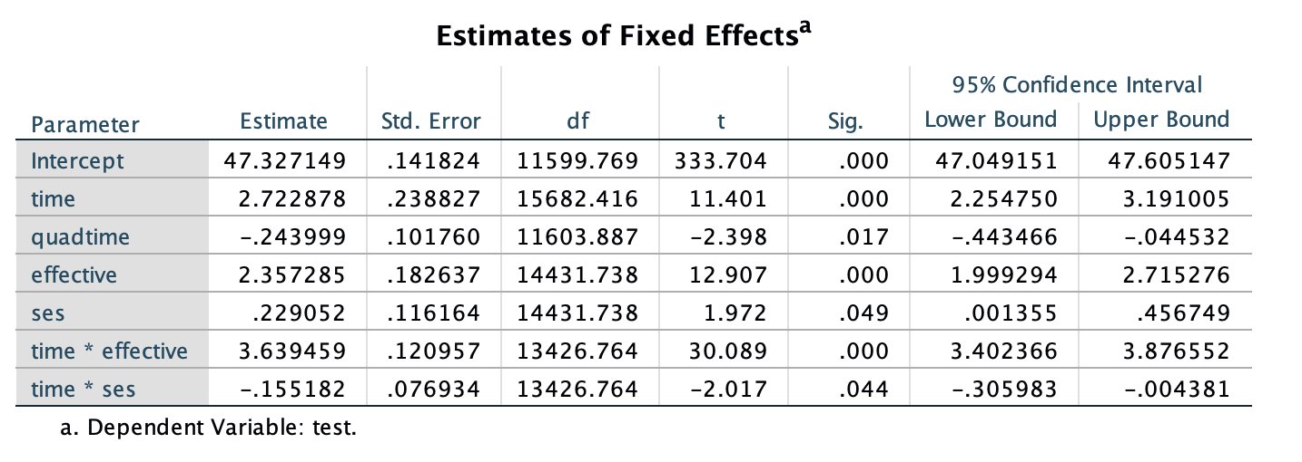

* + Model 3

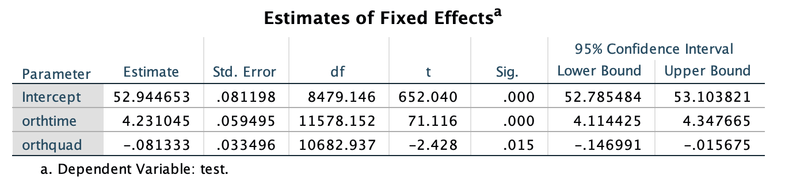

* + Model 4

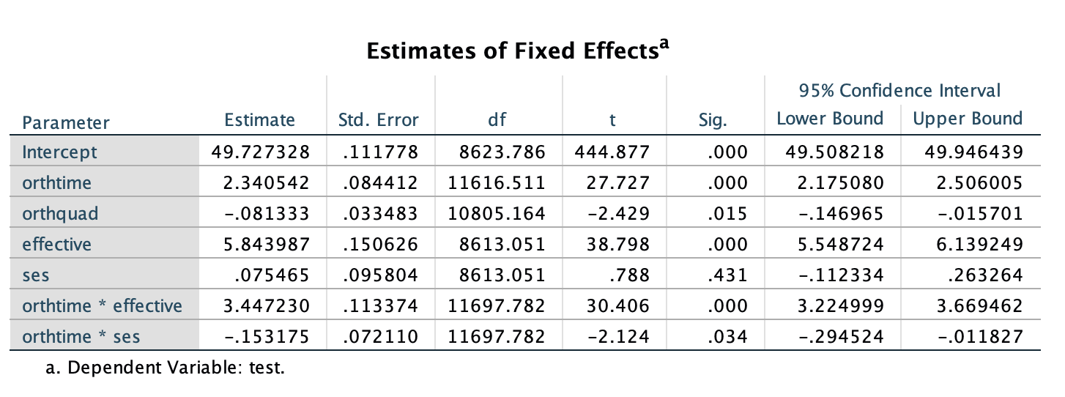

* + Model 5

# 

* Interpretation:
  + According to the AIC, model 5 is the best model.
  + The fixed effect of orthtime, orth quadratic time, effect, and the interaction effect of orthtime and ses, orthtime and effective, and orth quadratic and effective are significant.

# Problem 2: Research Proposal

## Purpose & Research Question

The purpose of this study is to examine the relationship between resource and research publication for the academic institution. The research question for this study can be summarized as: (1) To what extent, does the resource available vary in difference countries? (2) What is the independent effect of the research resource on research publication, controlling on the school background?

## Literature Review and Theory

In a global knowledge economy, colleges and universities are important players in the international marketplace of ideas and talents (Altbach et al., 2010). The importance of higher education institutions to national development has been recognized by many developing and middle-income countries worldwide. Sustained investment in higher education institutions can lead to dramatic growth in research publications. For example, according to a recent report by Thomson Reuters (Adams et al. 2013), research output from China, as measured by number of papers aggregated by the Web of Knowledge, accounted for about 11 % of worldwide research publications between 2007 and 2011, which this number is slightly over 1% in the 1990s. In some fields such as material science and chemistry, more than 20 % of all research papers have authors from China.

The revenue theory of costs (Bowen 1980) suggests that universities spend all the money they can raise to maximize excellence, prestige, and influence. However, with no clear definition and standard of these abstract goals, this view does not offer strong predictions regarding institutions would prioritize their resources to produce outputs that maximize prestige. Empirical studies found that universities tend to use their internal resources to invest in research that builds reputation (Ehrenberg et al. 2007; Zhang and Ehrenberg 2010). Meanwhile, theories do not tell us how institutional behaviors are influenced by the resources involving financial (e.g., R&D funding) and human resources (e.g., graduate student enrollment).

## Data

How to collecting the corresponding data is a challenge. For the institution level data: there are several widely used university rankings, if we narrow down our scope to the higher educational institution only. The three longest established and most influential global rankings are those produced by Shanghai Ranking Consultancy (the Academic Ranking of World Universities; ARWU), Times Higher Education (THE), and Quacquarelli Symonds (QS). All of these, along with other global rankings, primarily measure the research performance of universities rather than their teaching. All of these rankings are annually reported. Taking ARWU as an example, it includes the number of articles published by Nature or Science and the number of Nobel Prize winners and Fields Medalists (mathematics). One of the primary criticisms of ARWU's methodology is that it is biased towards the natural sciences and English language science journals over other subjects. For the missing data which is not available for the database of these institutions, we may need to find the data source individually for the corresponding institutions or countries. For example, detailed information on research production and resource information for the top research-orientated educational institution in China is funded and supervised by China’s Ministry of Education (MOE). Country level data usually are available from the bureau of statistics for each corresponding government. For example, bureau of economics analytics under the US department of commerce provides the information about GDP, personal income, international trade, consumer spending, and the data under the special topics (e.g., cultural, art, health, and well-being).

## Method

In this study, we can use the hierarchical linear growth model, which allows us to investigate the different growth of research publication across different country and different institutions. For simplicity, there is no interaction effect will be included into the model and at most the quadratic component is used. Meanwhile, to reduce the strong correlations between the components, polynomials are transformed to be orthogonal. The covariance type for both random variable and repeated variable are unconstructed. At level one (institution level), thee systematic growth for publication can be expressed as

, where is the number of publications for the institution at year , is the intercept describing the average initial status mean between institutions, is a vector of fixed effects of time-fixed institutional variables (e.g., the institution type as state level, national level, or international level), is vector of fixed effects of the time-varying variables (e.g., D&R funding and graduate student enrollment for the institution at year ), and is the linear and quadratic time effects, and are variation associated with estimating the intercept and slope parameter between institutions.

## Implication

This model enables us to estimate the independent effect of institution resource (e.g., D&R funding and graduate student enrollment) on number of research publication by controlling the effects from time change and other institution background information (e.g., institution type).